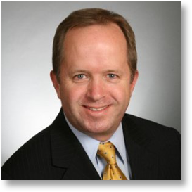

James Rea
jrea@expertsclearly.com
For more than 20 years, James has rooted around in dense thickets of scientific and public policy content, searching for the stories that shine. He found this calling in 1996 at the US Environmental Protection Agency, where he translated vital scientific research into language the public would understand and remember. James further honed his skills as an independent reporter for National Public Radio, crafting stories most often for WAMU 88.5 FM in Washington, DC. As the 21st century dawned, James founded the production firm SiteStories to help technical organizations share their stories through web videos. By 2011, James had interviewed countless experts. He knew how to find the gold in their stories, and wanted to help them do the same. He now follows this passion through his own firm Experts/Clearly, and as an instructor with Alda Communication Training.

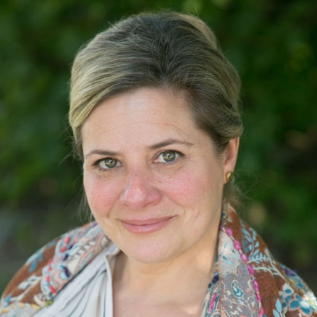

Lydia Franco-Hodges
Lydia.franco-hodges@stonybrook.edu
Lydia works with scientists throughout the country enhancing their communication skills through improvisation and theater techniques. Lydia is an associate of the Alan Alda Center, a lecturer in the School of Journalism, and an actor and theater-maker. She teaches graduate courses for the Alda Center at Stony Brook University. Lydia has taught acting, movement and performance at the university for many years and applauds the work created by her students.

